1. Which company had the most sales during the year 2000? How has their market share
changed over time based on the available data?
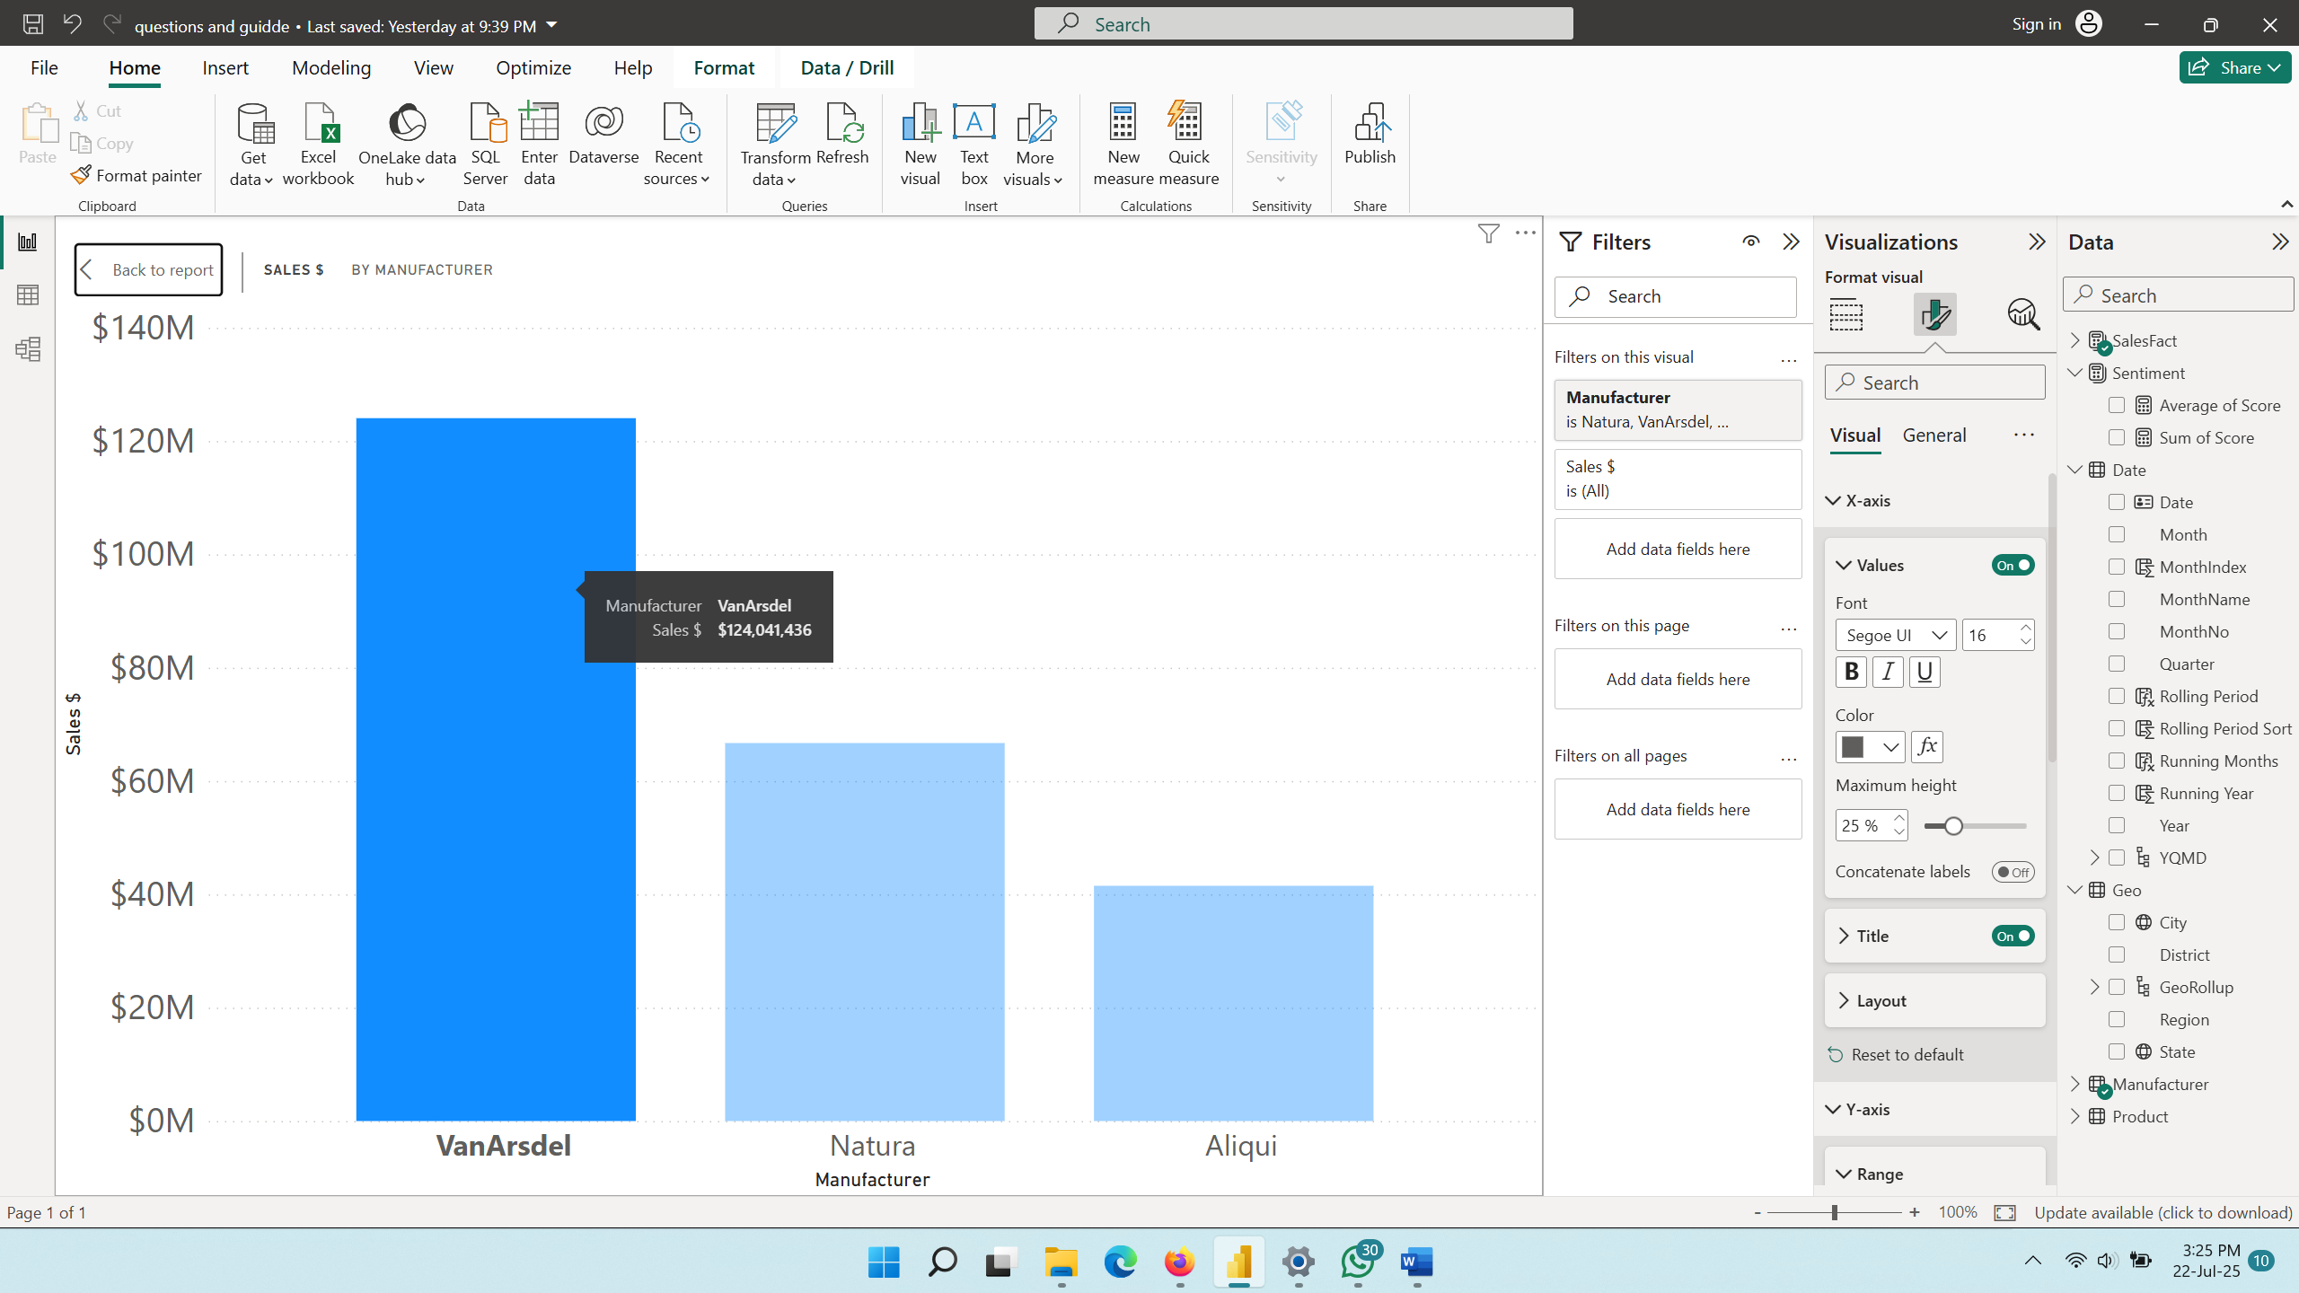

VanArsdel company had the most sales in year 2000 with a total of $124,042,436.
For the Q1 from Jan – Mar, the sales recorded $10,767,733, $6,811,109, $9,468,194.

January recorded high sales, but there was a decline in February, which prompted a change in strategy in March. Although not as high as January recorded, but far superior to sales at the end of the second quarter.

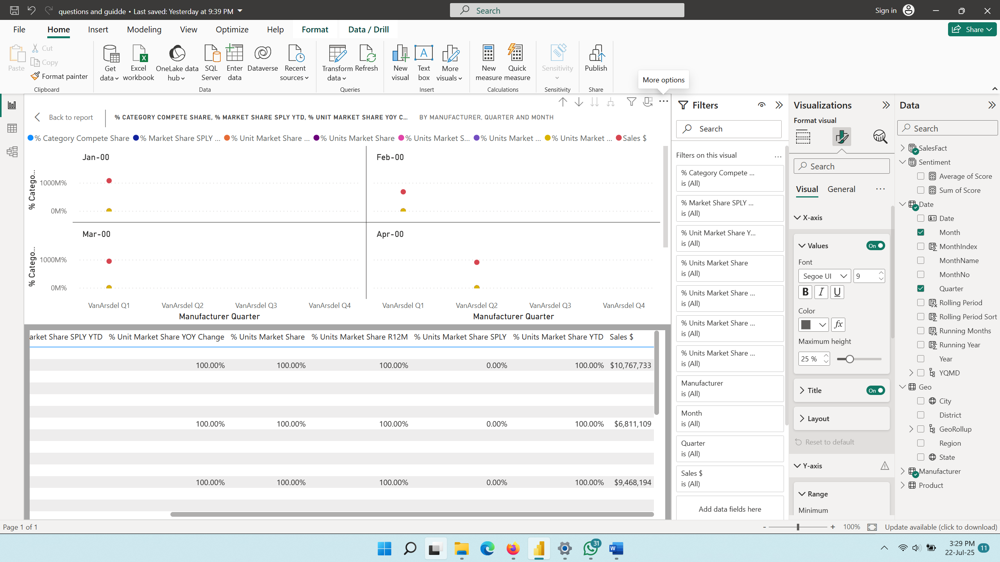
For the Q2 from April– June, the sales recorded $9,083,974, $9,217,908, and $7,006,626.
Q2 started with an adequate amount in April and a slight bump in May, but had a decline in June.
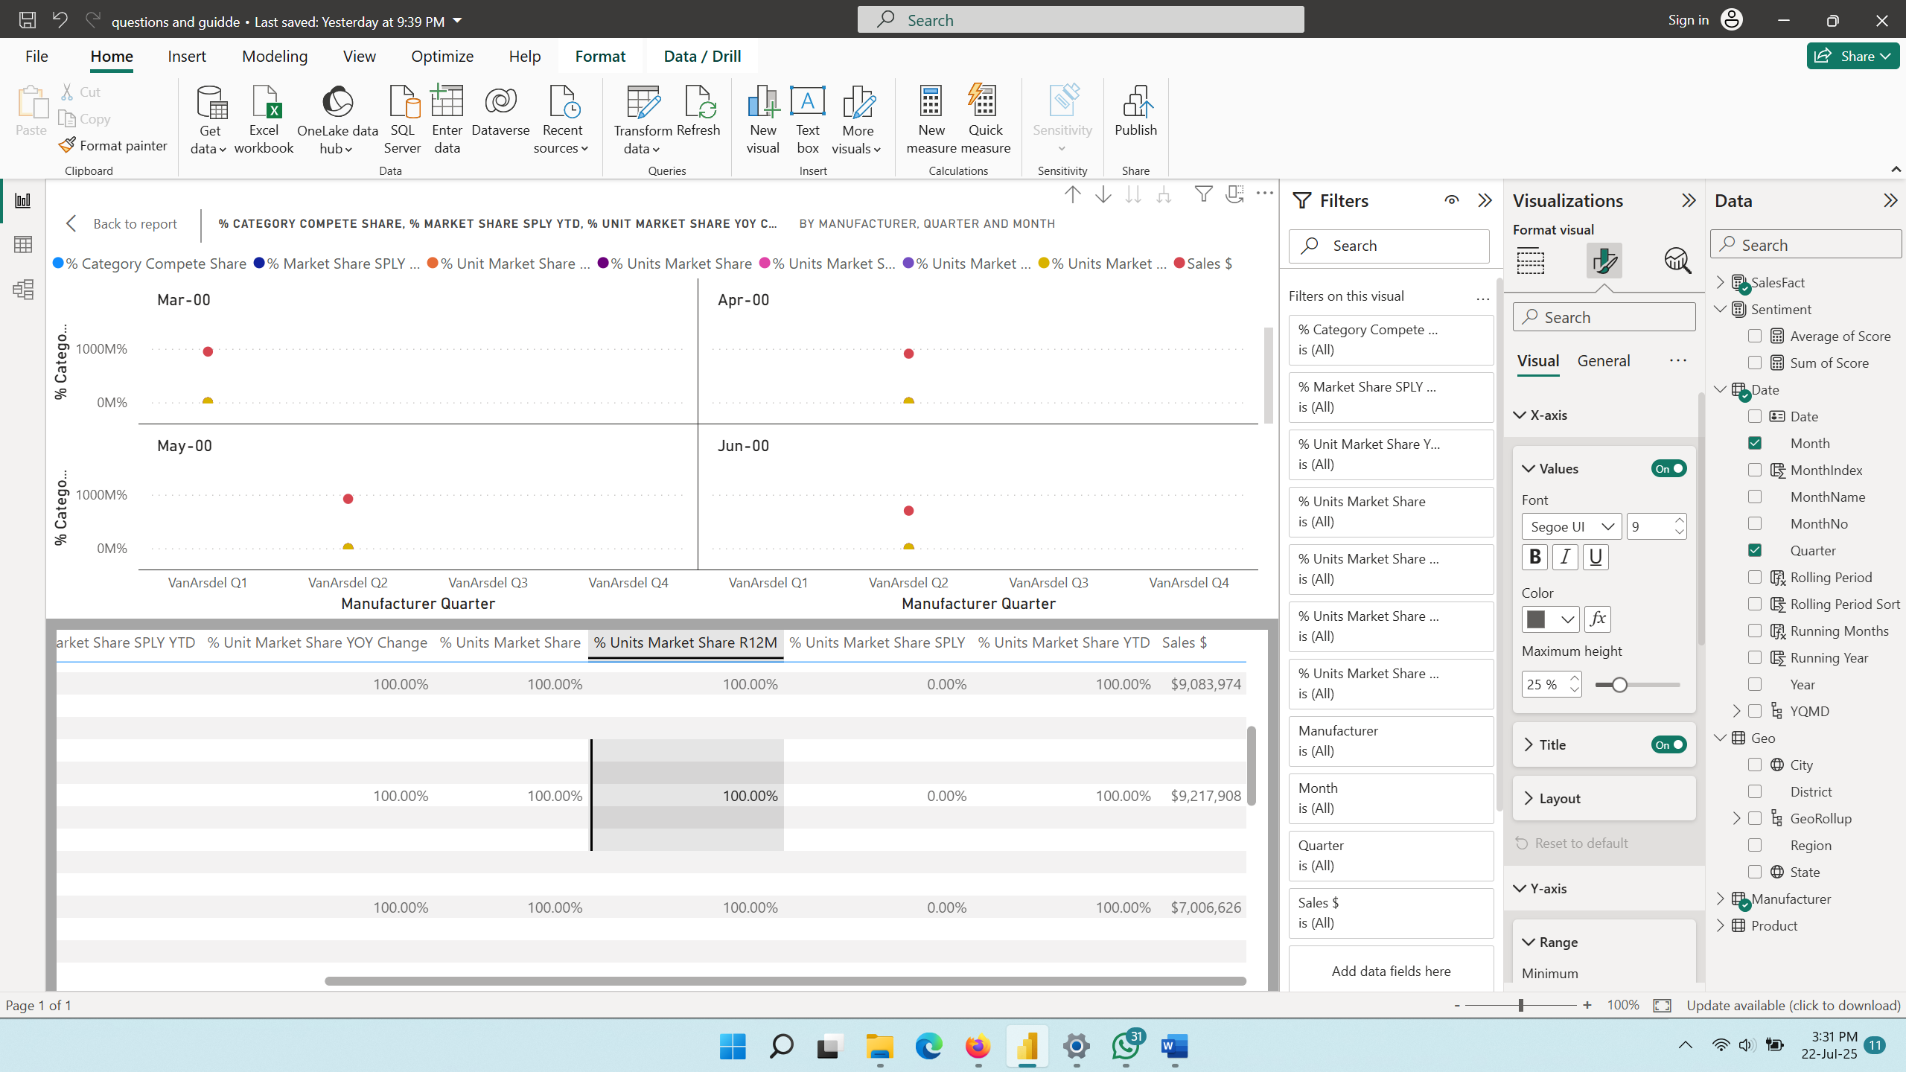
For the Q3 from July – Sept, the sale recorded $9,957,728 $10,391,339 $12,158,618
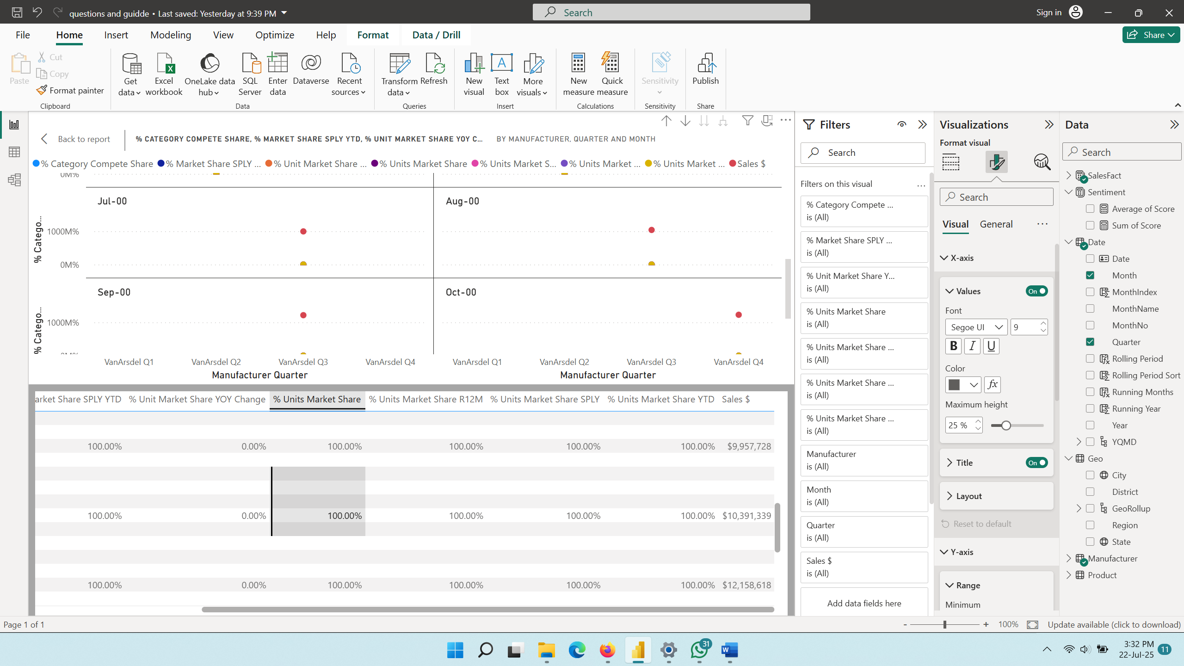
Q3 started with an adequate amount of sales for slightly closer to 8 figures, which was achieved in August, and a large increase in September.

For the Q4 from October – December, the sale recorded $12,280,267 $13,565,490 $13,332,449
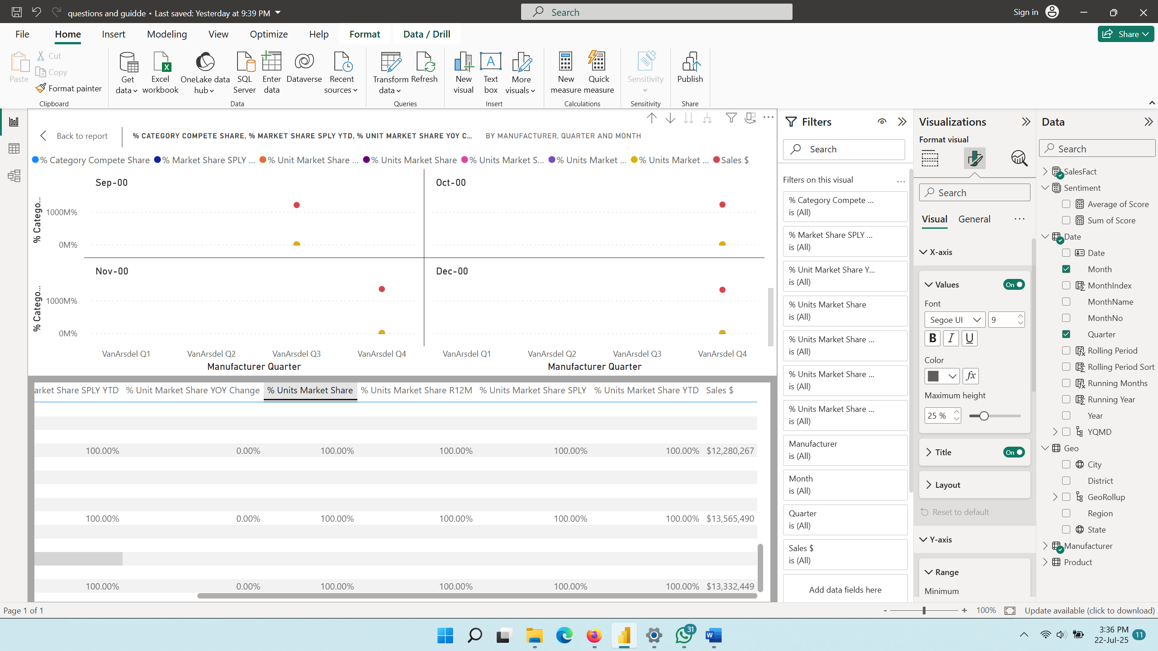
In the last quarter of 2000, sales maintained a higher level after carefully reviewing the strategies that had worked in the year.

2. Compare the top three manufacturers based on total overall sales. Then, compare them based
on total sales within each product category and region. Is there anything noticeable about the
visualizations? What might these visualizations tell us about the strategy of each manufacturer?

The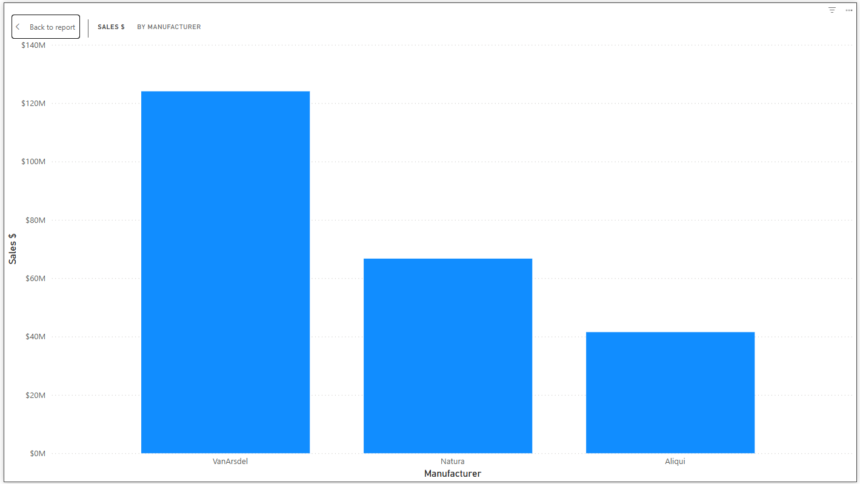The top three manufacturers are VanArsdel,Natura,Aliqui

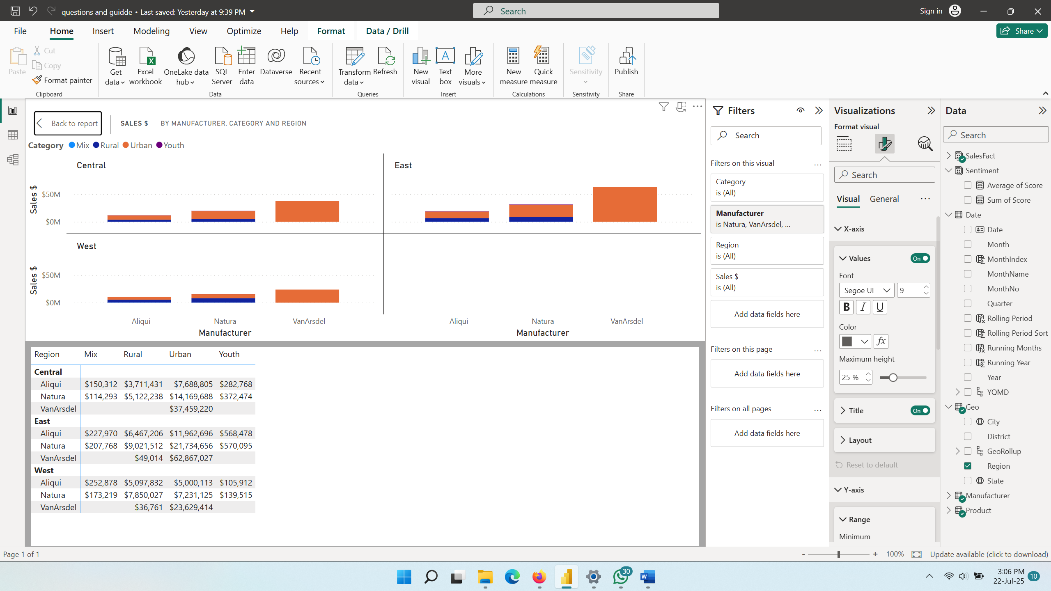

What is noticed is that VanArsdel recorded the most sales from the top 3 and also had the most sales by category and region, with all of its sales happening in the urban category. Natura and Aliqui made sales in rural areas and across other categories.
The numbers are slighly different,no number below is higher than the one above

3.Some states have noticeably lower average sentiment scores than others. Is there a correlation
between the lower sentiment scores and some other metric? If so, explain the correlation. If not,
choose a couple of examples to compare and show the lack of correlation.


The numbers are slighly different,no number below is higher than the one above
The observation of the correlation across the states shows there is a descending order in the average sentiment score, although the metric is inconsistent.

